Azure Fundamentals Lab Manual
Hands-on Lab: Virtual Machine, Azure SQL Database, Blob Storage, and a Simple HTML Website
All exercises use the Azure Portal (no command line required).

Table of Contents
Table of Contents 1
Introduction 1
What You Will Build 1
Prerequisites 1
Conventions Used in This Manual 1
Lab 1: Create a Virtual Machine 1
Step 1: Sign In and Start the Wizard 1
Step 2: Configure the Basics Tab 1
Step 3: Review and Create 1
Step 4: Connect to the VM 1
Lab 2: Create an Azure SQL Database 1
Step 1: Start the Wizard 1
Step 2: Configure the Basics Tab 1
Step 3: Configure Networking 1
Step 4: Review, Create, and Query 1
Lab 3: Blob Storage and Image Upload 1
Step 1: Create a Storage Account 1
Step 2: Create a Container 1
Step 3: Upload an Image 1
Lab 4: Deploy a Simple HTML Website 1
Step 1: Prepare a Sample HTML File 1
Step 2: Enable Static Website Hosting 1
Step 3: Upload the HTML File 1
Step 4: View the Site 1
Cleanup Checklist 1
Option A: Delete the Entire Resource Group (Recommended) 1
Option B: Delete Resources Individually 1
Summary 1
Further Reading 1

Introduction
This lab manual is a guided, hands-on introduction to four core Azure services. Every step is performed in the Azure Portal using point-and-click navigation — no scripting or command-line tools are required. By the end of this lab you will have created a virtual machine, an Azure SQL database, a storage account with image upload, and a simple HTML website hosted on Azure.

What You Will Build
Lab | Outcome
Lab 1: Virtual Machine | A running Windows or Linux VM you can connect to remotely
Lab 2: Azure SQL Database | A cloud SQL database with a server, accessible via Query editor
Lab 3: Blob Storage | A storage account and container with an image file uploaded
Lab 4: Simple HTML Deployment | A static HTML page published to a public URL

Prerequisites
- An active Azure subscription (a free trial or pay-as-you-go subscription both work).
- Permission to create resources in at least one resource group.
- A modern web browser (Edge, Chrome, or Firefox).
- One small image file (JPG or PNG) saved on your computer, for Lab 3.
- A short HTML file, for Lab 4 (a sample is provided in Lab 4).
Warning — Cost Control
Every resource created in this lab manual incurs cost while it is running. Follow the Cleanup Checklist at the end of this document to delete resources when you are finished, especially the virtual machine and the SQL database.

Conventions Used in This Manual
- Numbered steps describe actions to take in the Azure Portal.
- Yellow Note boxes provide helpful context or alternatives.
- Red Warning boxes flag cost or security considerations.
- Text in quotation marks (e.g. “Create a resource”) refers to exact buttons, menu items, or labels in the portal.

Lab 1: Create a Virtual Machine
In this lab, you will deploy a virtual machine (VM) running Windows Server or Ubuntu Linux directly from the Azure Portal.

Step 1: Sign In and Start the Wizard
- Go to the Azure Portal at portal.azure.com and sign in with your Azure account.
- In the search bar at the top of the page, type “Virtual machines” and select it from the results.
- On the Virtual Machines page, select “+ Create”, then choose “Azure virtual machine” from the dropdown.

Step 2: Configure the Basics Tab
- Under Project details, select your Subscription.
- For Resource group, select “Create new” and enter a name, for example LabResourceGroup.
- Under Instance details, enter a Virtual machine name, for example MyLabVM.
- Choose a Region close to you.
- For Image, select a Windows Server image (e.g. Windows Server 2022 Datacenter) or Ubuntu Server (e.g. Ubuntu Server 22.04 LTS).
- Leave the default Size, or select “See all sizes” and choose a small, low-cost size such as B1s for lab purposes.
- Under Administrator account, enter a Username and a Password (or upload an SSH public key if using Linux). The password must be at least 12 characters and meet complexity requirements.
- Under Inbound port rules, allow the relevant inbound port: RDP (3389) for Windows, or SSH (22) for Linux.

Step 3: Review and Create
- Select “Review + create” at the bottom of the page.
- Wait for validation to pass, then review the configuration summary.
- Select “Create”.
- Wait for the deployment to complete (typically 1–3 minutes), then select “Go to resource”.

Step 4: Connect to the VM
- On the VM Overview page, select “Connect”.
- For Windows, choose RDP, download the RDP file, and open it with Remote Desktop Connection using the username and password you set.
- For Linux, choose SSH and follow the connection command shown, using an SSH client such as PuTTY or a terminal.
Note
If RDP or SSH connection fails, confirm the inbound port rule was created and that your network allows outbound connections on that port.
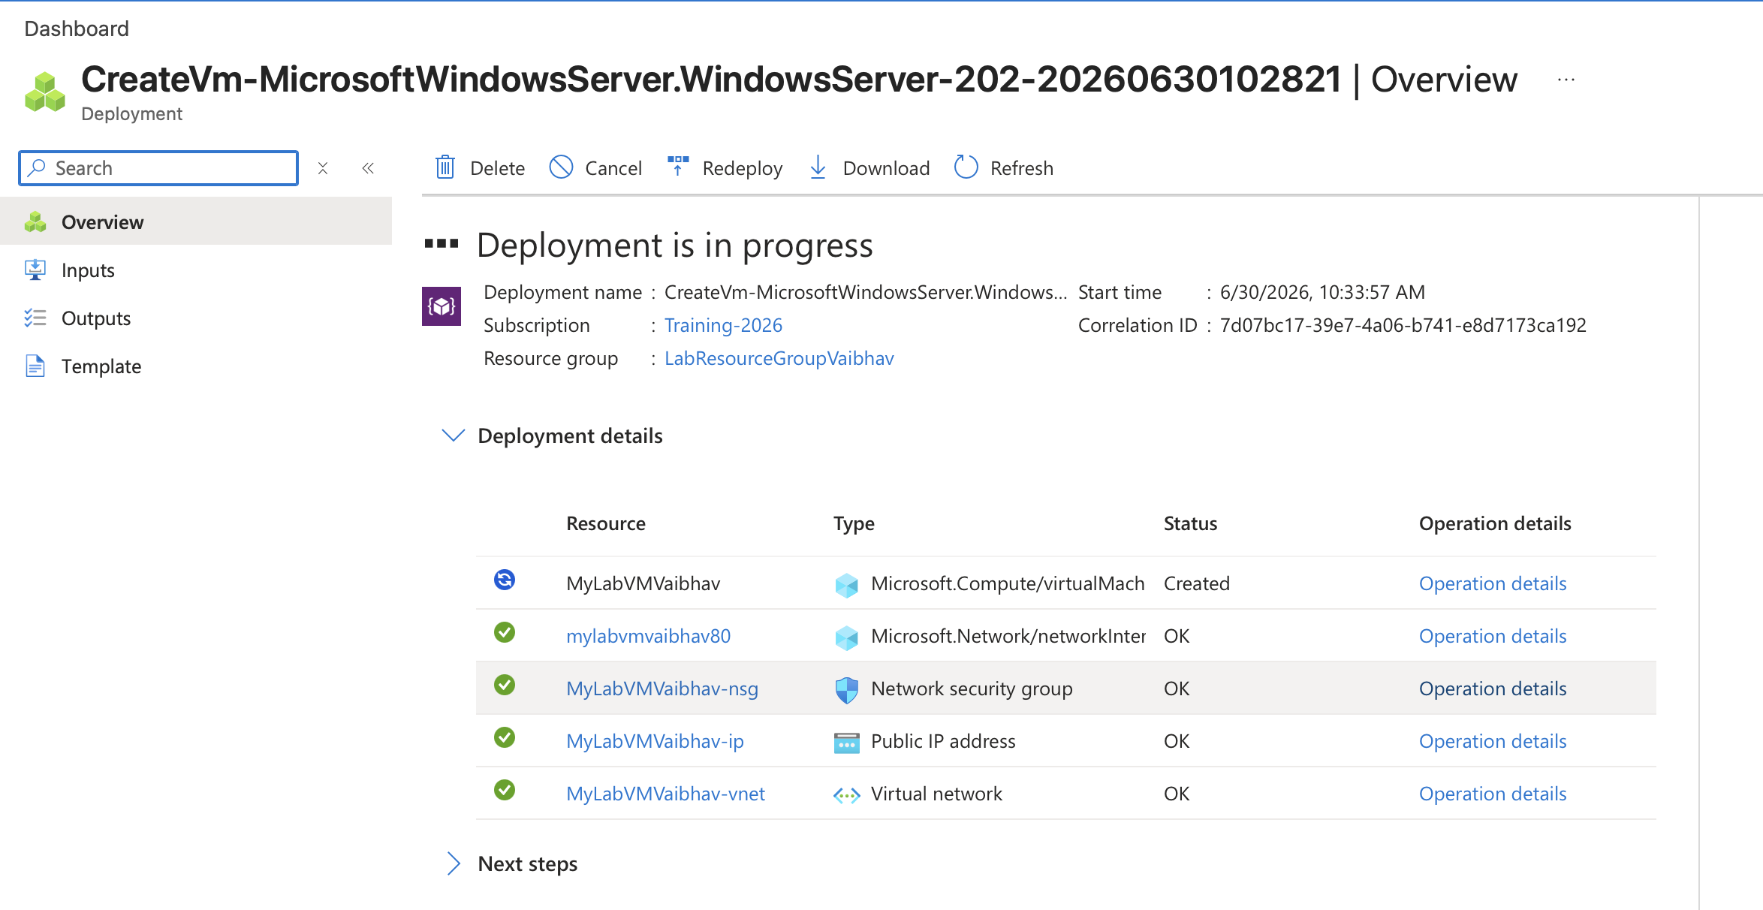
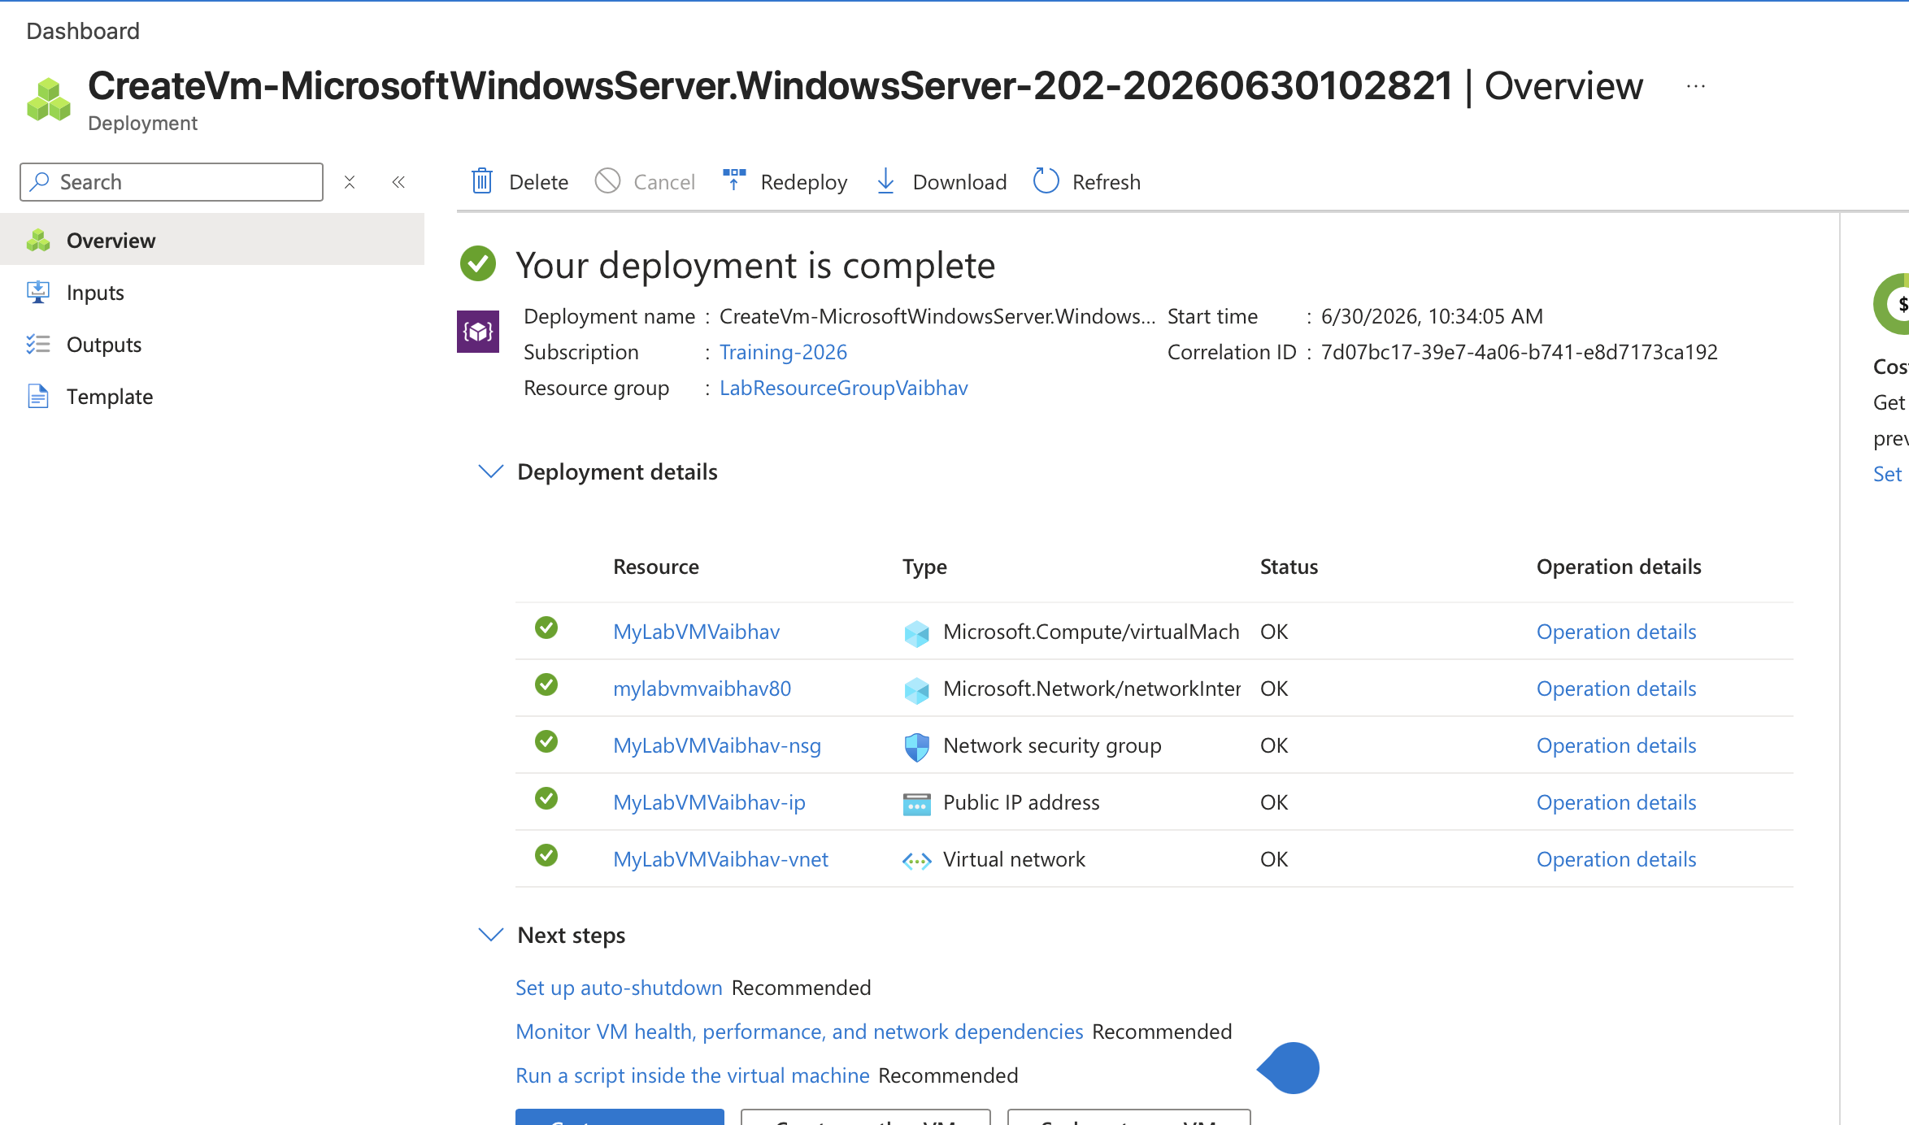
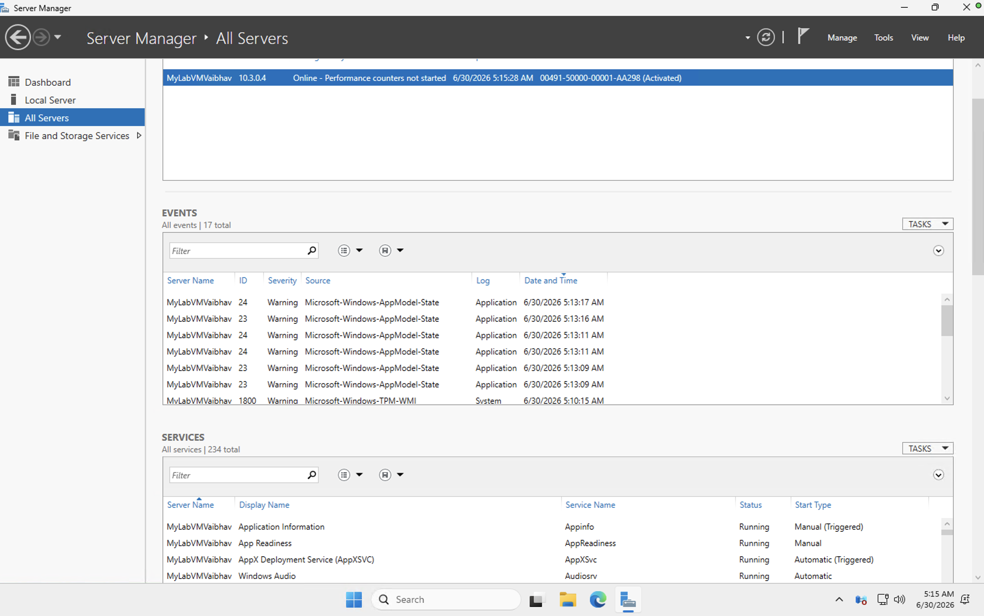
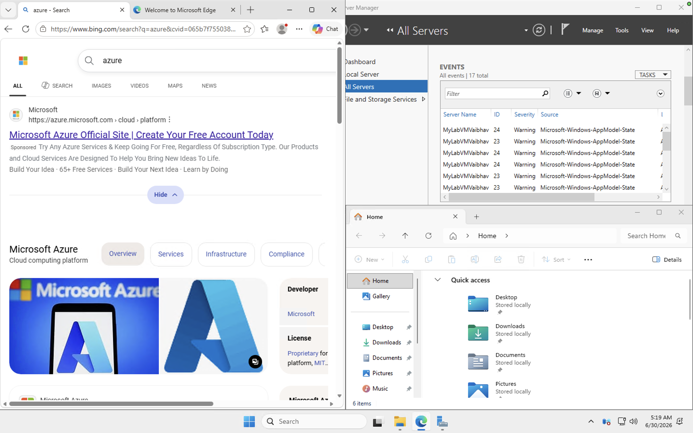

Lab 2: Create an Azure SQL Database
In this lab, you will create a logical SQL server and a single Azure SQL Database, then query it using the built-in Query editor — entirely in the browser.

Step 1: Start the Wizard
- In the Azure Portal search bar, type “SQL databases” and select it.
- Select “+ Create”.

Step 2: Configure the Basics Tab
- Select your Subscription.
- For Resource group, select the same resource group used in Lab 1, or create a new one.
- Under Database details, enter a Database name, for example mySampleDatabase.
- Next to Server, select “Create new”. Enter a unique Server name, choose a Location, select an authentication method (SQL authentication is simplest for a lab), and set a Server admin login and Password. Select “OK”.
- Leave “Want to use SQL elastic pool?” set to No.
- Under Compute + storage, select “Configure database”, choose the General Purpose tier with Serverless compute, and select the smallest vCore option to minimize cost. Select “Apply”.
- Under Backup storage redundancy, choose Locally-redundant backup storage (lowest cost for a lab).

Step 3: Configure Networking
- Select the “Networking” tab.
- For Connectivity method, select “Public endpoint”.
- Set “Allow Azure services and resources to access this server” to Yes.
- Set “Add current client IP address” to Yes so you can connect from your own machine.

Step 4: Review, Create, and Query
- Select “Review + create”, wait for validation, then select “Create”.
- Once deployment finishes, select “Go to resource”.
- On the database Overview page, select “Query editor (preview)” in the left menu.
- Sign in using the SQL admin login and password you created.
- In the query window, run a simple test query, for example: SELECT @@VERSION;, then select “Run” to confirm the database is working.
Note
The Query editor runs entirely in the browser, so no database client software is required for this lab.
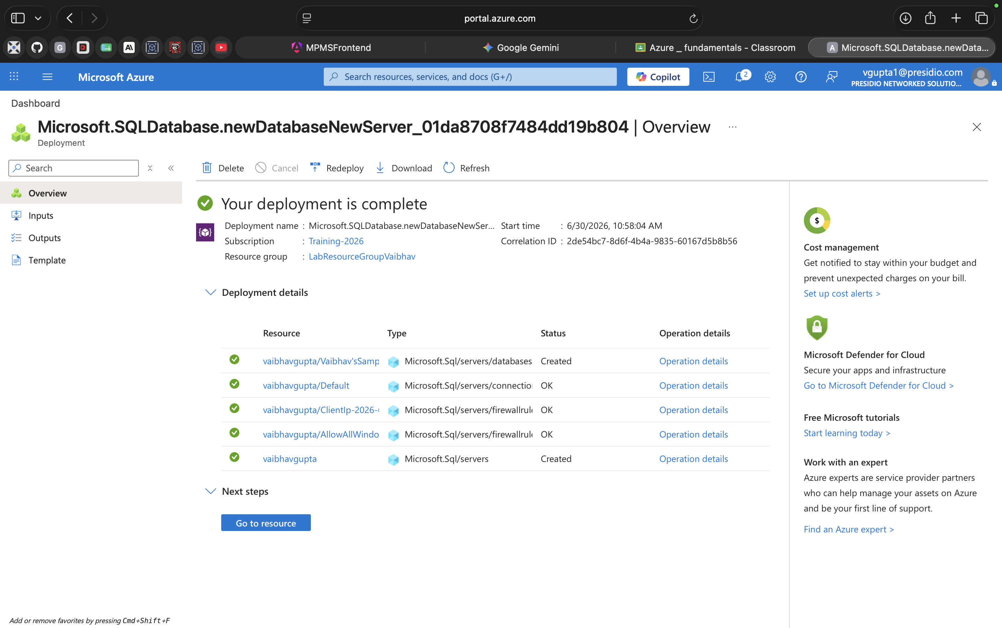
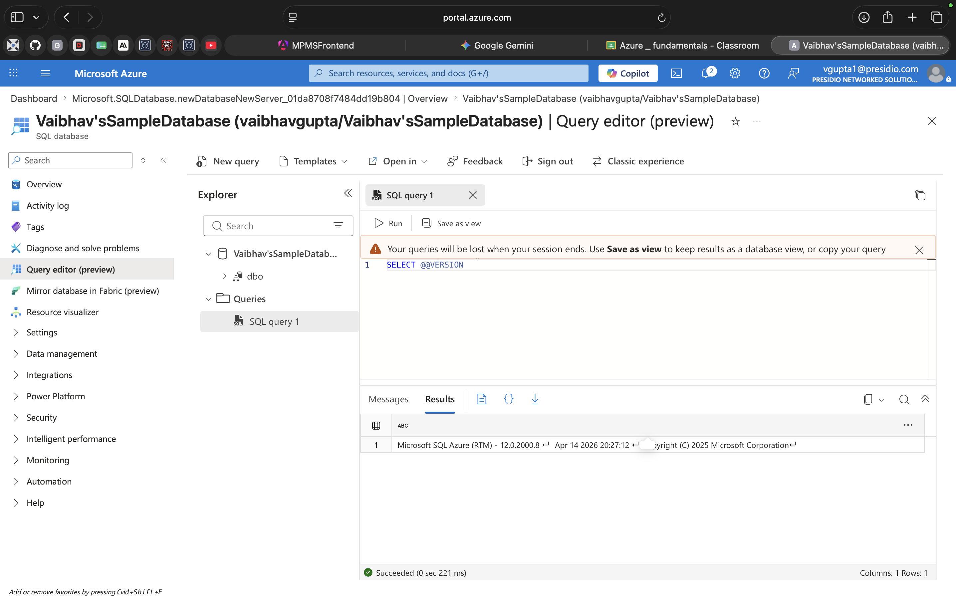

Lab 3: Blob Storage and Image Upload
In this lab, you will create a storage account, add a container, and upload an image file as a blob.

Step 1: Create a Storage Account
- In the Azure Portal search bar, type “Storage accounts” and select it.
- Select “+ Create”.
- Select your Subscription and the resource group from Lab 1.
- Enter a globally unique Storage account name (lowercase letters and numbers only, e.g. mylabstorage2026).
- Choose a Region close to you.
- Leave Performance set to Standard and Redundancy set to Locally-redundant storage (LRS) for a low-cost lab setup.
- Select “Review”, then “Create”, and wait for deployment to finish.
- Select “Go to resource”.

Step 2: Create a Container
- In the left menu of the storage account, under Data storage, select “Containers”.
- Select “+ Container”.
- Enter a name, for example images (lowercase letters, numbers, and dashes only).
- Leave the default Public access level (Private), then select “Create”.

Step 3: Upload an Image
- Select the new container to open it.
- Select “Upload”.
- Browse to the image file on your computer (JPG or PNG) and select it.
- Select “Upload” to complete the operation.
- Select the uploaded blob in the list to view its properties and copy its URL.
Note
If the container's public access level is Private, the blob URL will not be publicly viewable in a browser. To make an individual image viewable via its URL, set the container access level to “Blob” (anonymous read access for blobs only) when creating it, or change it afterward under container Settings > Access level.
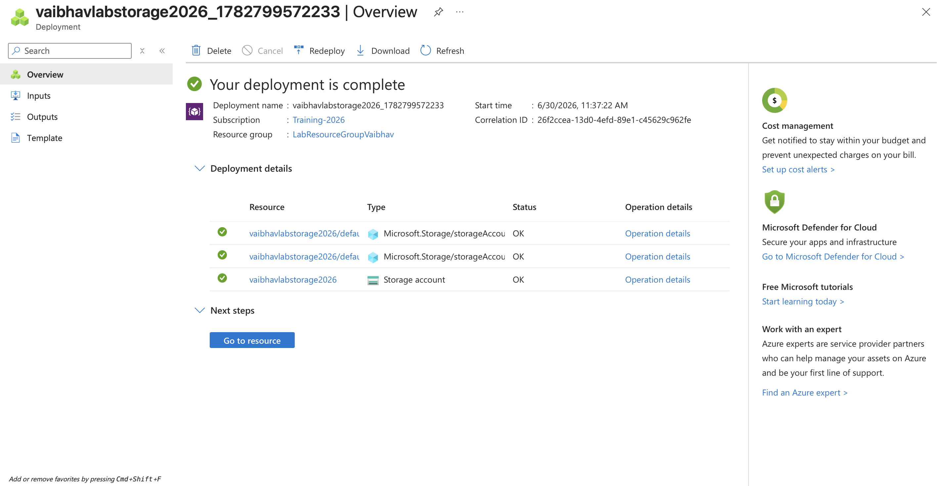
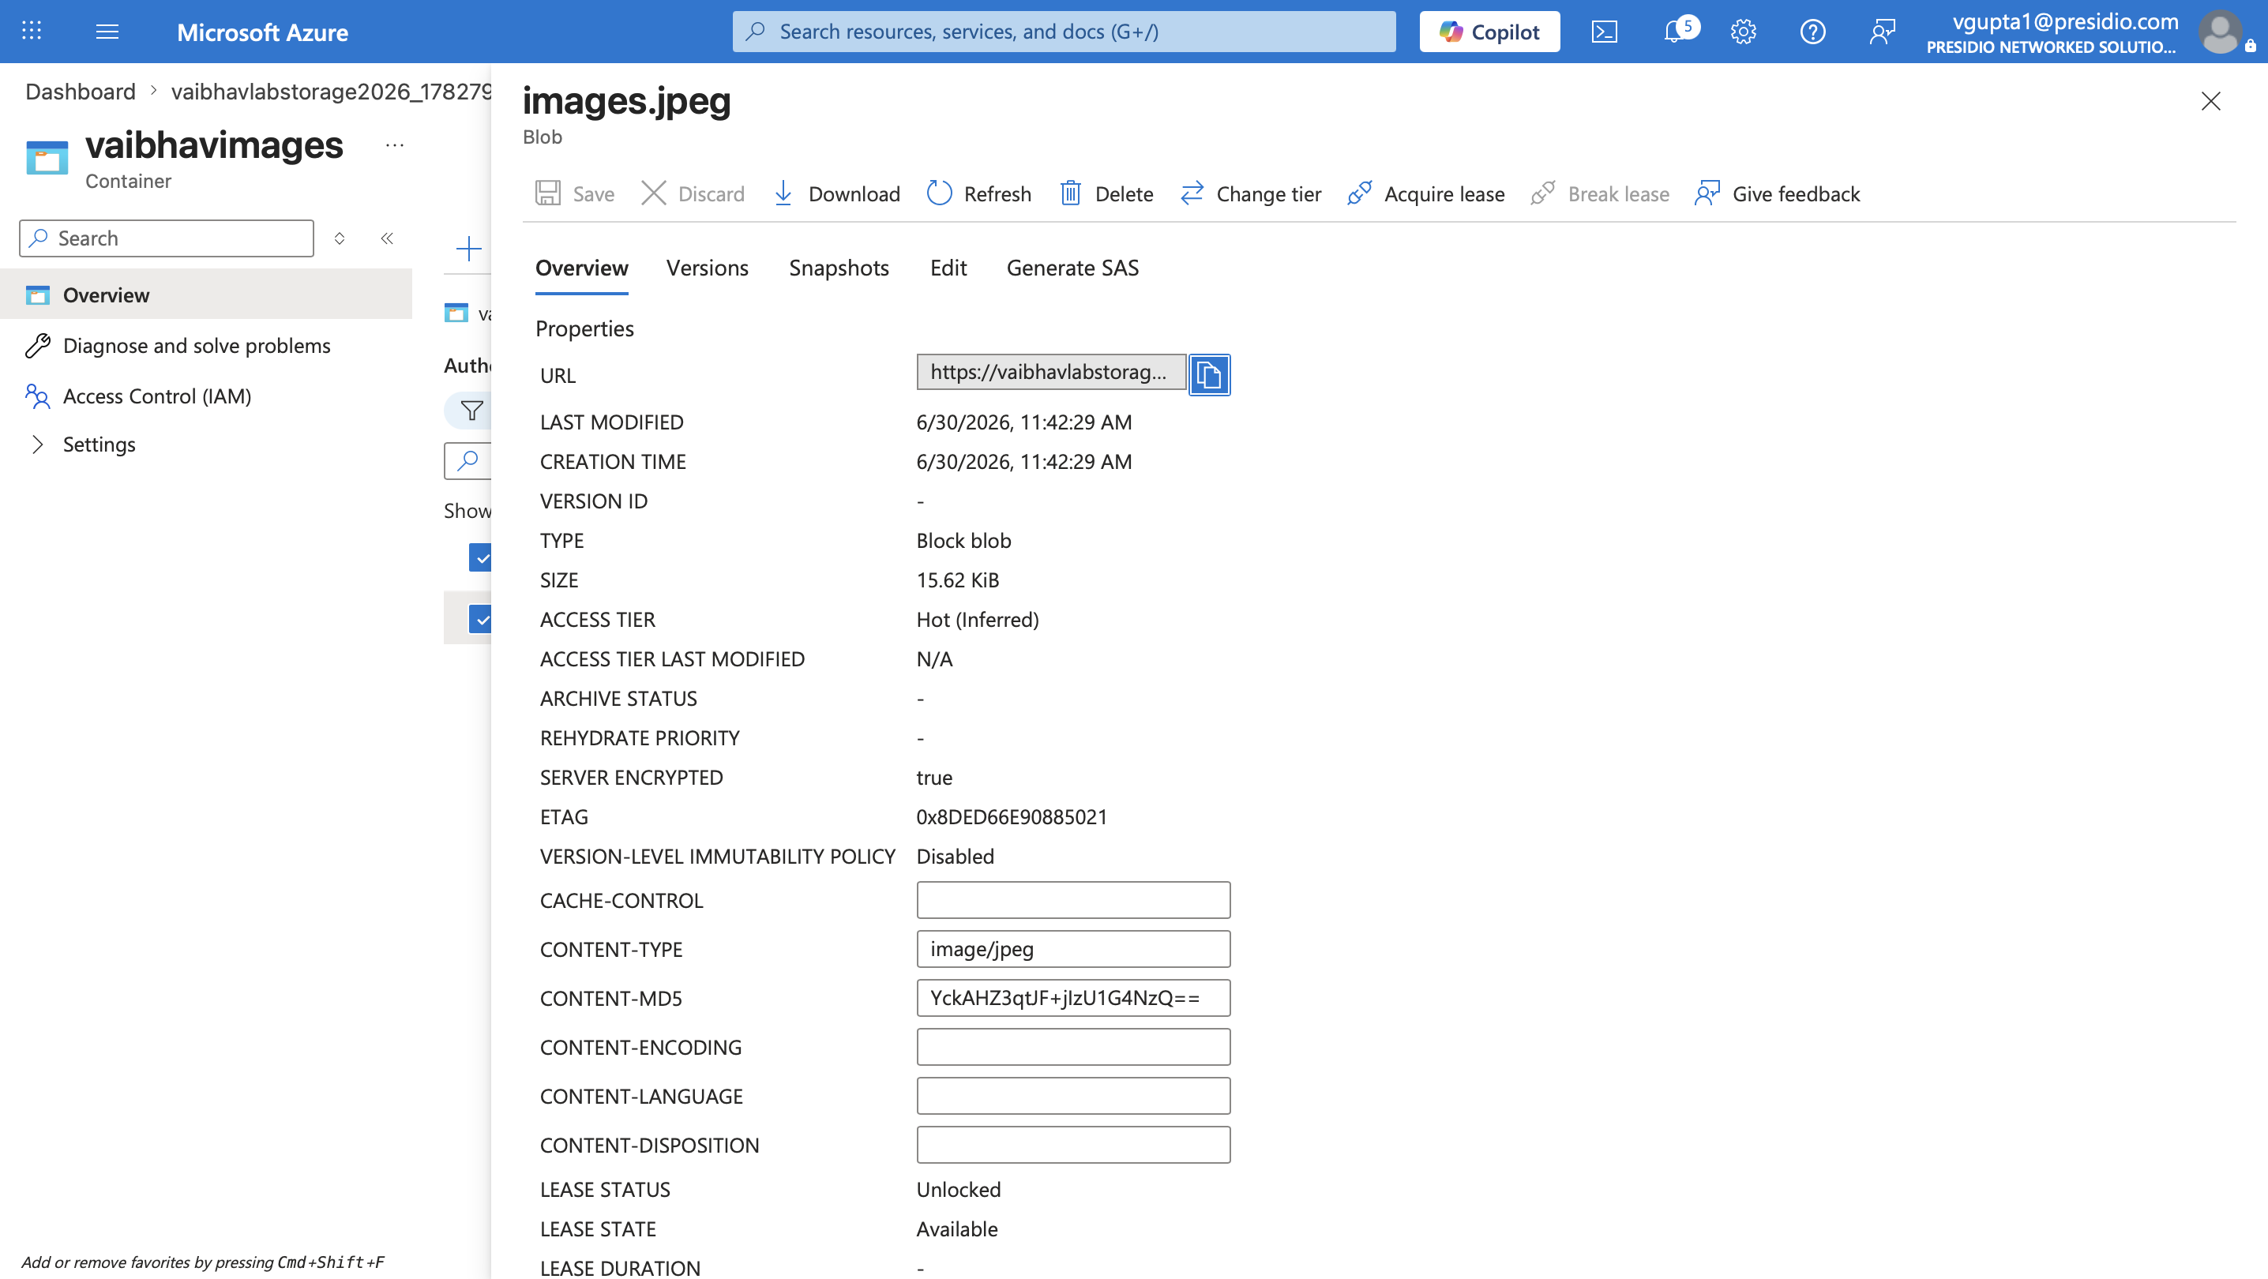
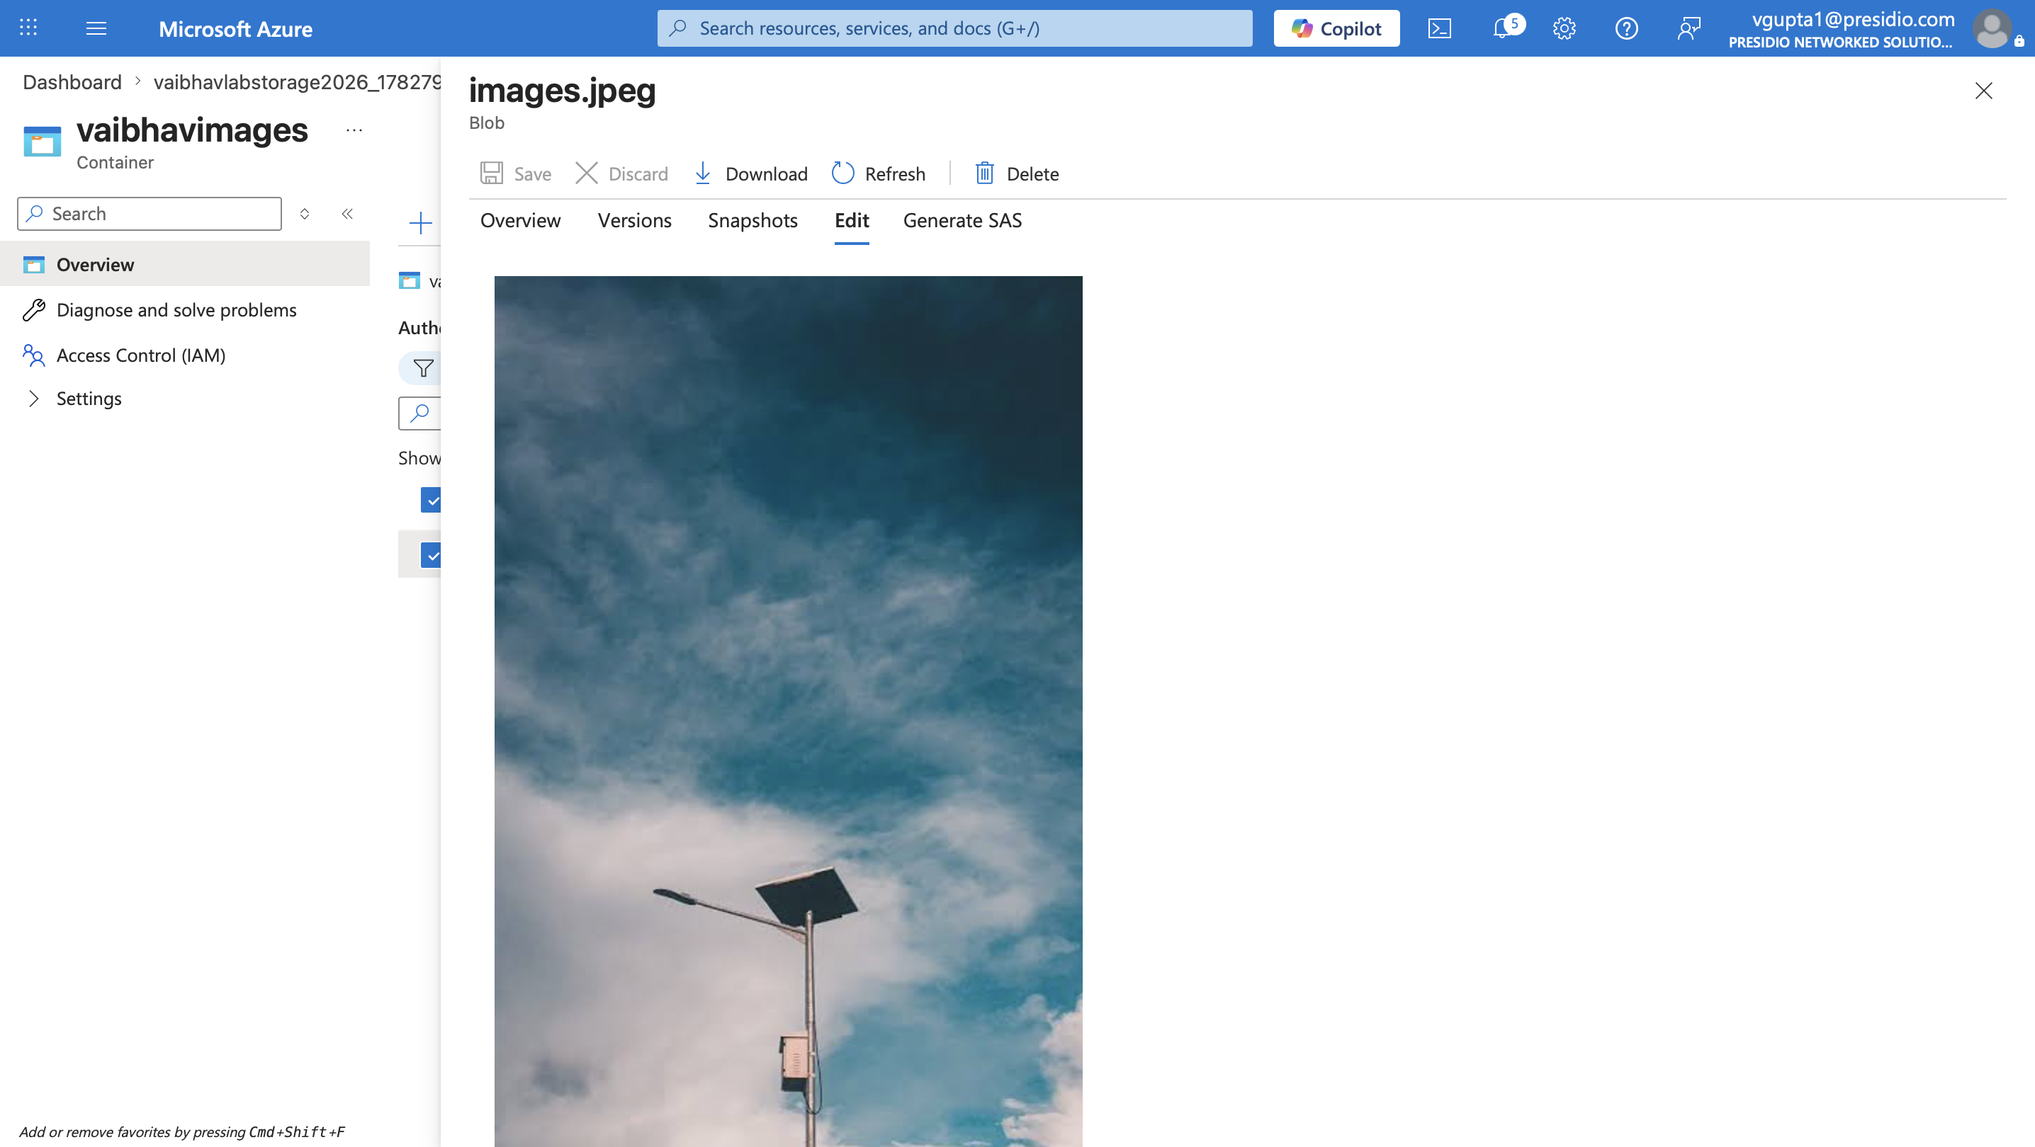

Lab 4: Deploy a Simple HTML Website
In this lab, you will publish a basic HTML page to the public internet using the static website feature of the storage account you created in Lab 3 — all from the portal, with no command-line deployment tools.

Step 1: Prepare a Sample HTML File
Create a text file named index.html on your computer with the following content, then save it:
<!DOCTYPE html> <html> <head><title>My Azure Lab Site</title></head> <body> <h1>Hello from Azure Blob Storage!</h1> <p>This page was deployed using static website hosting.</p> </body> </html>

Step 2: Enable Static Website Hosting
- Open the storage account created in Lab 3.
- In the left menu, under Data management, select “Static website”.
- Select “Enabled”.
- For Index document name, enter index.html.
- Select “Save”.
- Azure displays a Primary endpoint URL once saved — copy this URL; it is the public address of your site.

Step 3: Upload the HTML File
- After saving, return to the Static website page and select the link next to “$web container” (Azure automatically creates a container named $web for static content).
- Select “Upload”.
- Browse to your index.html file and select it.
- Select “Upload” to complete the operation.

Step 4: View the Site
- Return to the Static website page in the left menu of the storage account.
- Select or copy the Primary endpoint URL and open it in a new browser tab.
- Confirm that your HTML page renders correctly.
Note
The $web container is automatically configured for public, anonymous read access when static website hosting is enabled, so your page is reachable by anyone with the URL.
https://vaibhavlabstorage2026.z30.web.core.windows.net/
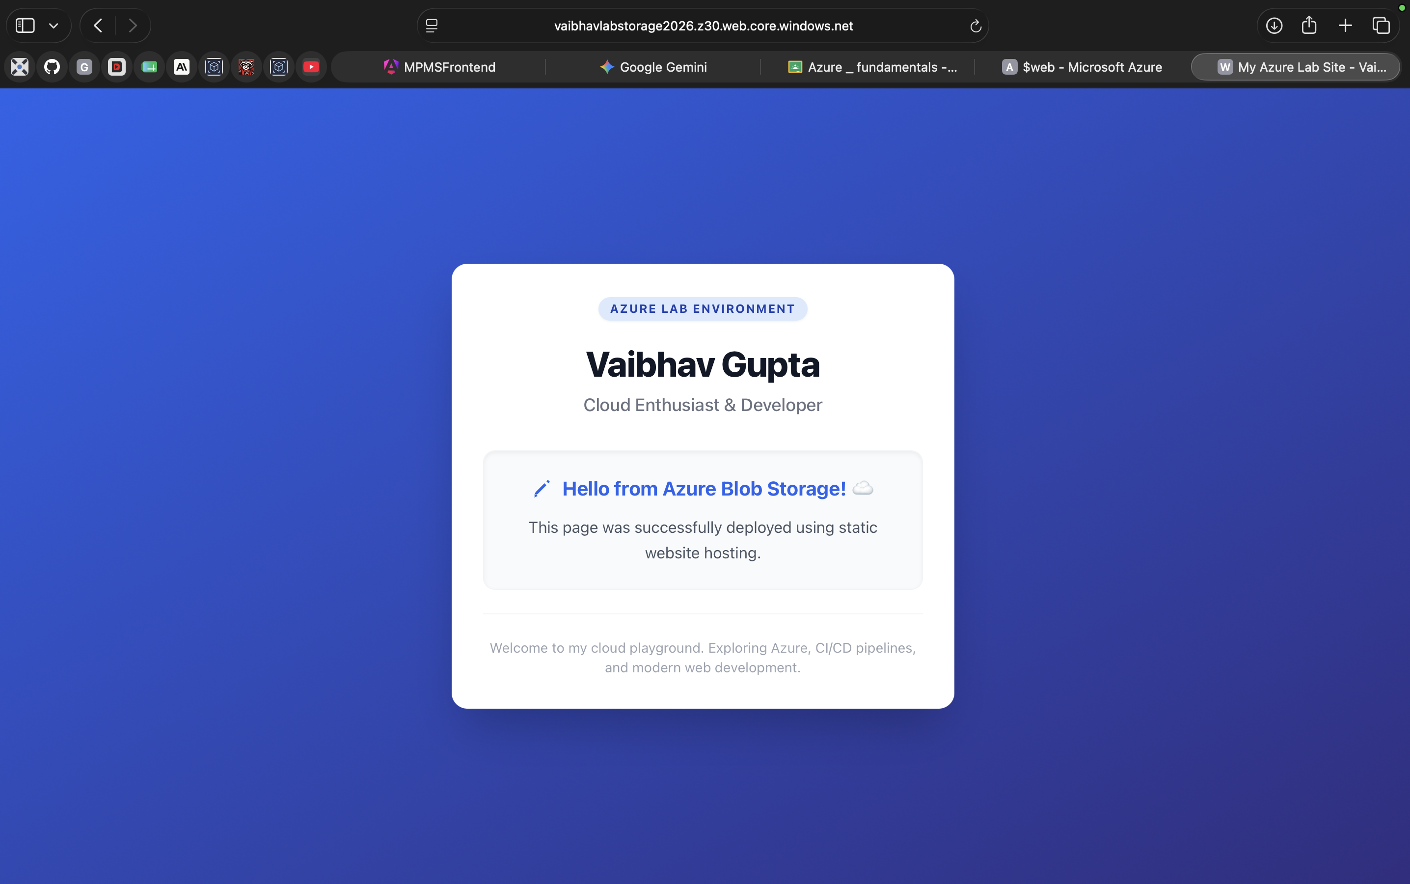

Cleanup Checklist
Azure resources continue to incur charges until they are deleted. When you have finished the lab, clean up resources to avoid unnecessary cost.

Option A: Delete the Entire Resource Group (Recommended)
- In the Azure Portal search bar, type “Resource groups” and select it.
- Select the resource group used throughout this lab (e.g. LabResourceGroup).
- Select “Delete resource group”.
- Type the resource group name to confirm, then select “Delete”.
Deleting the resource group removes the VM, SQL server and database, storage account, and all associated resources (disks, network interfaces, public IP addresses) in one step.
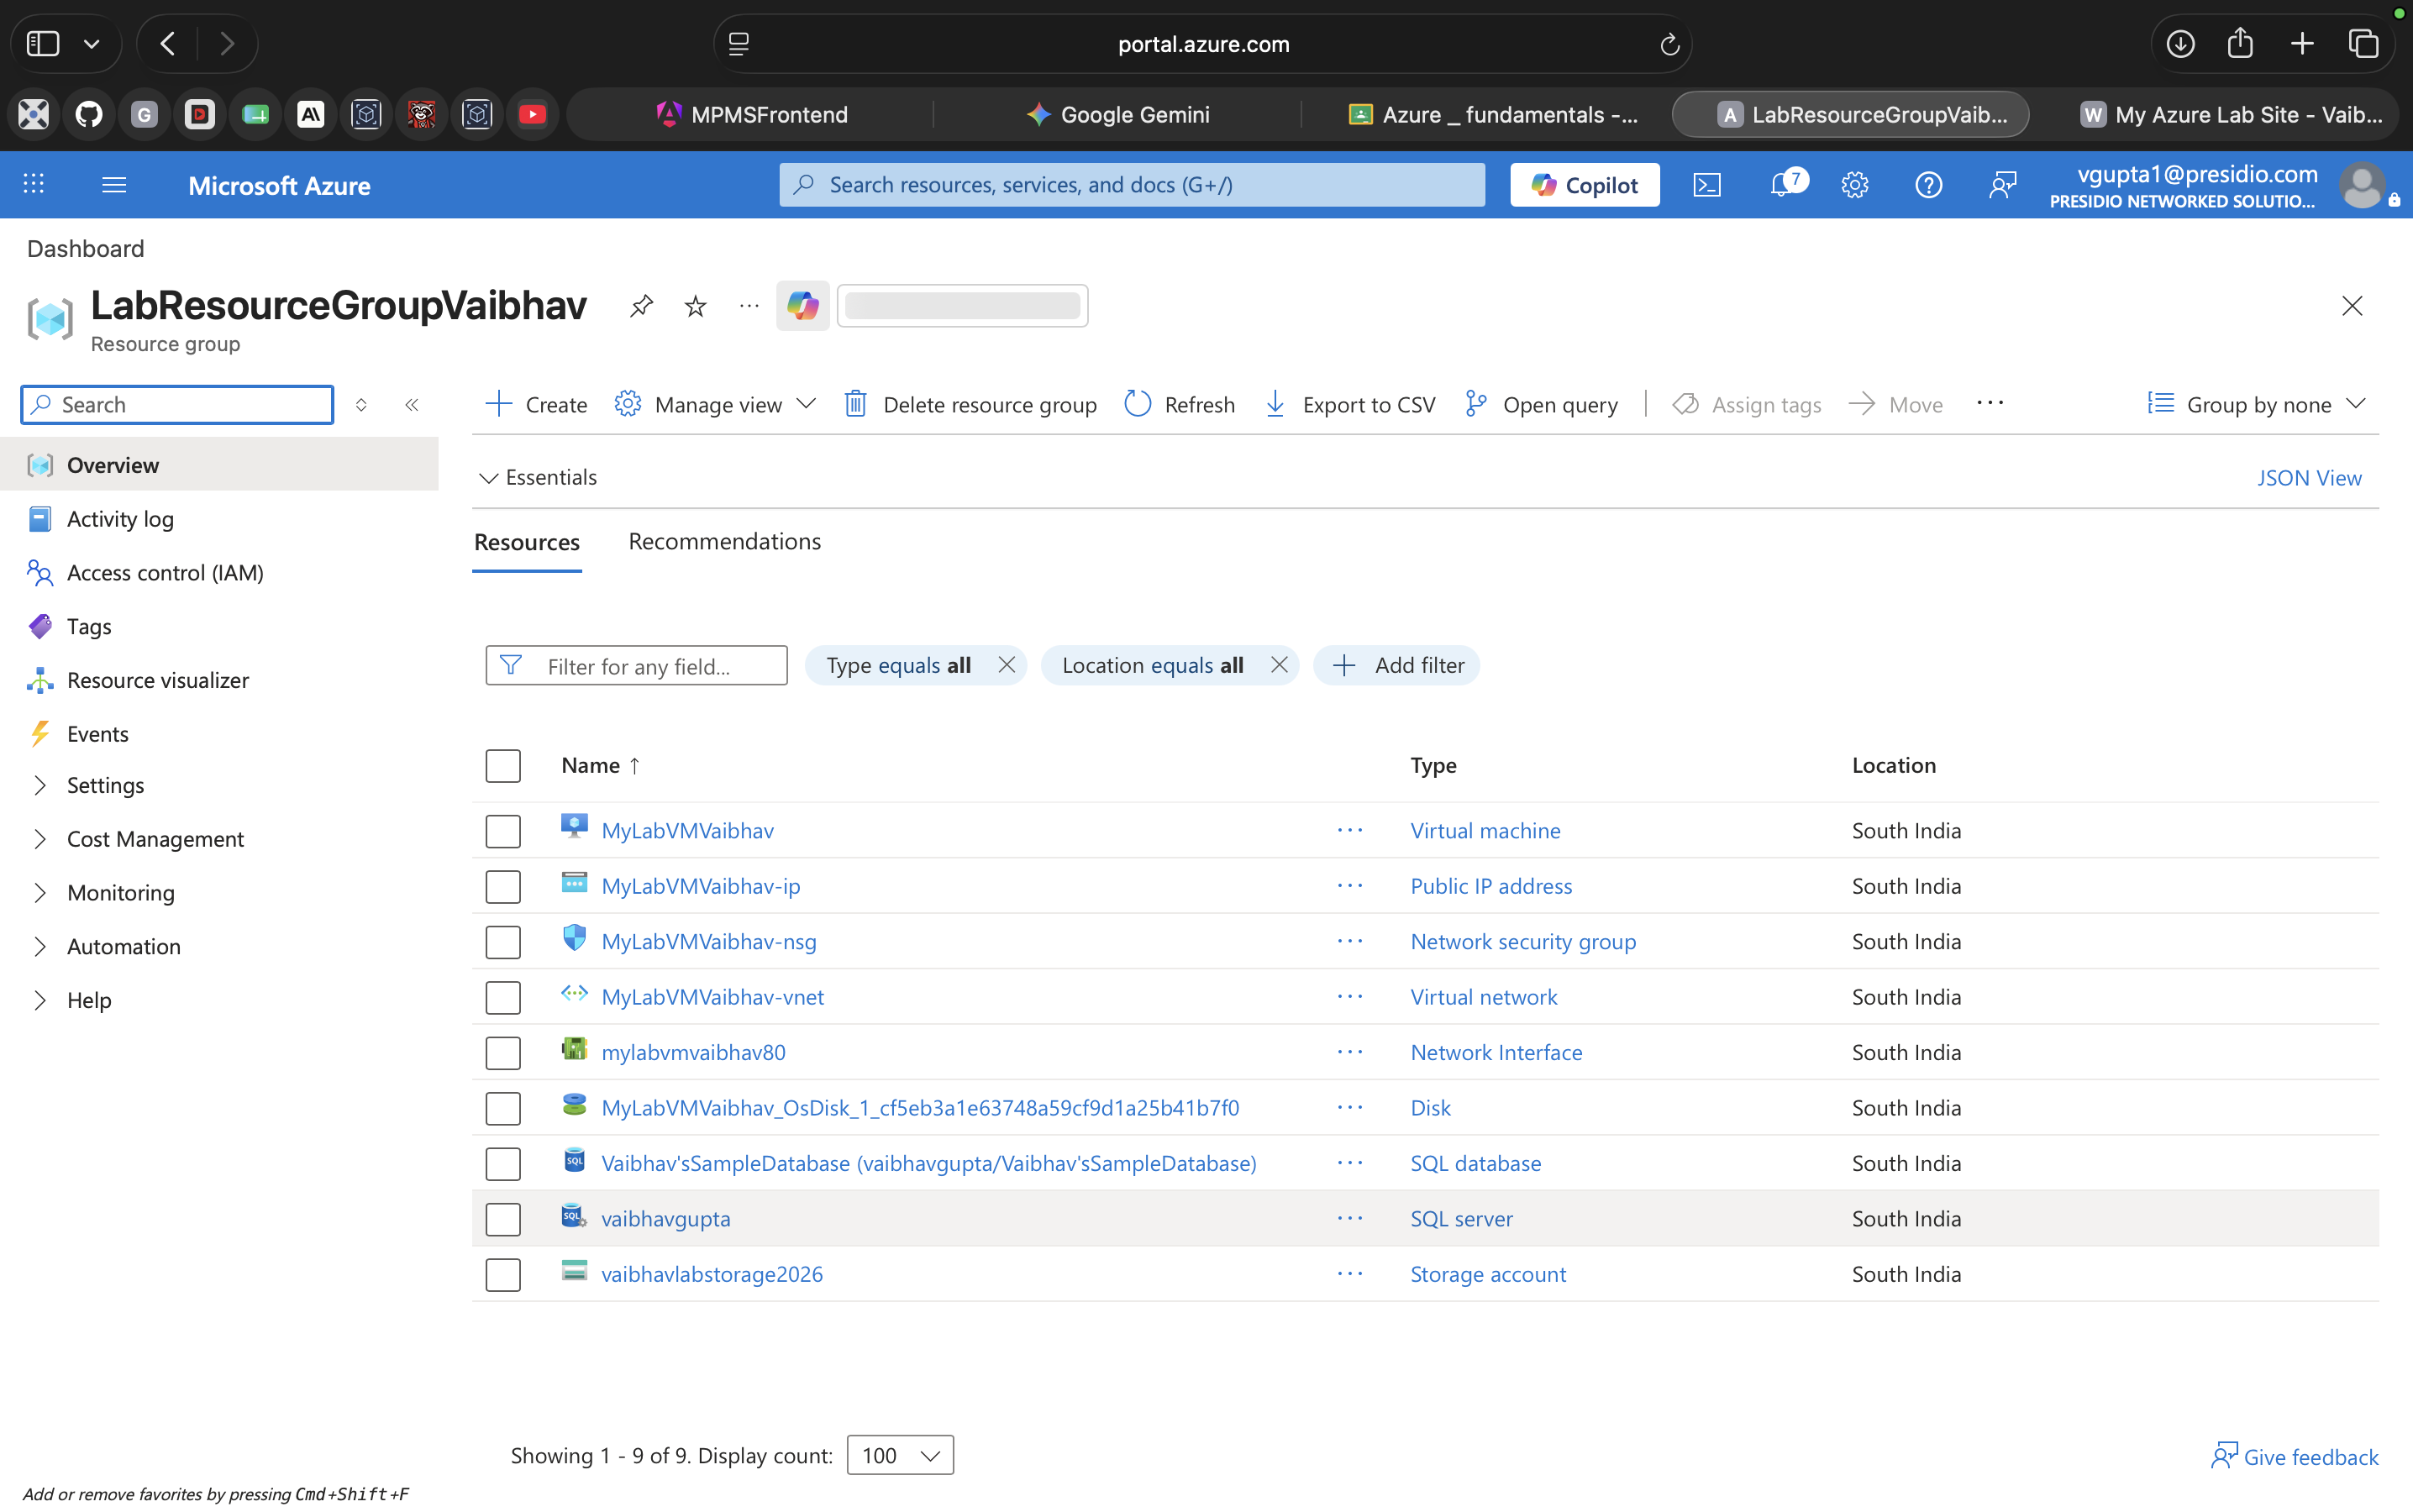
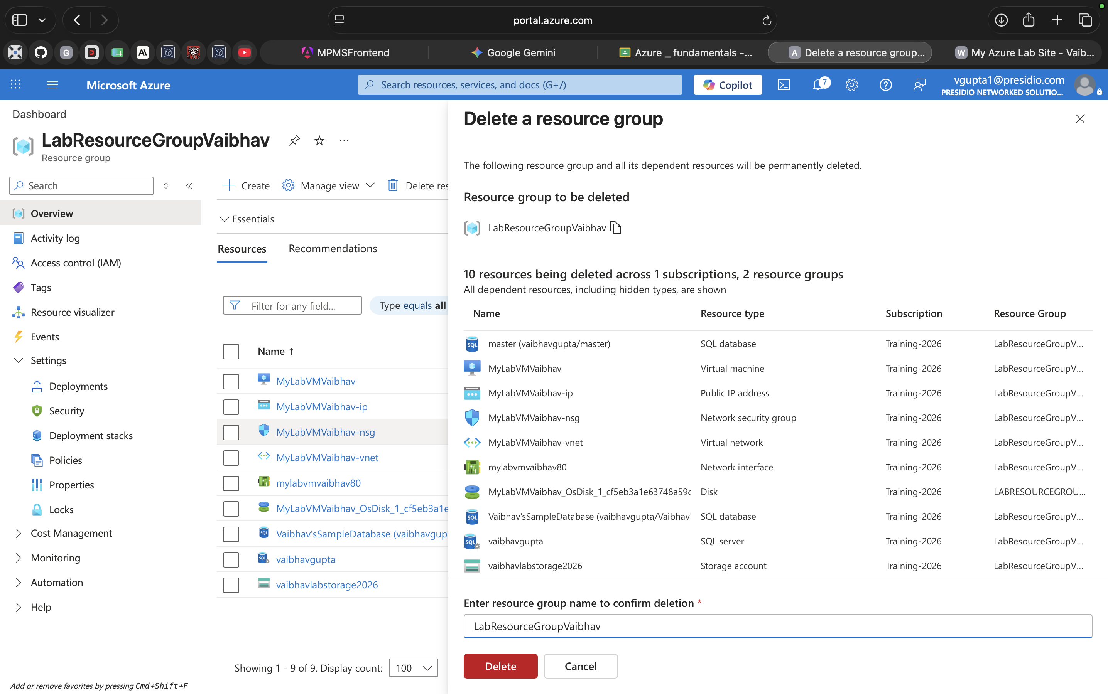
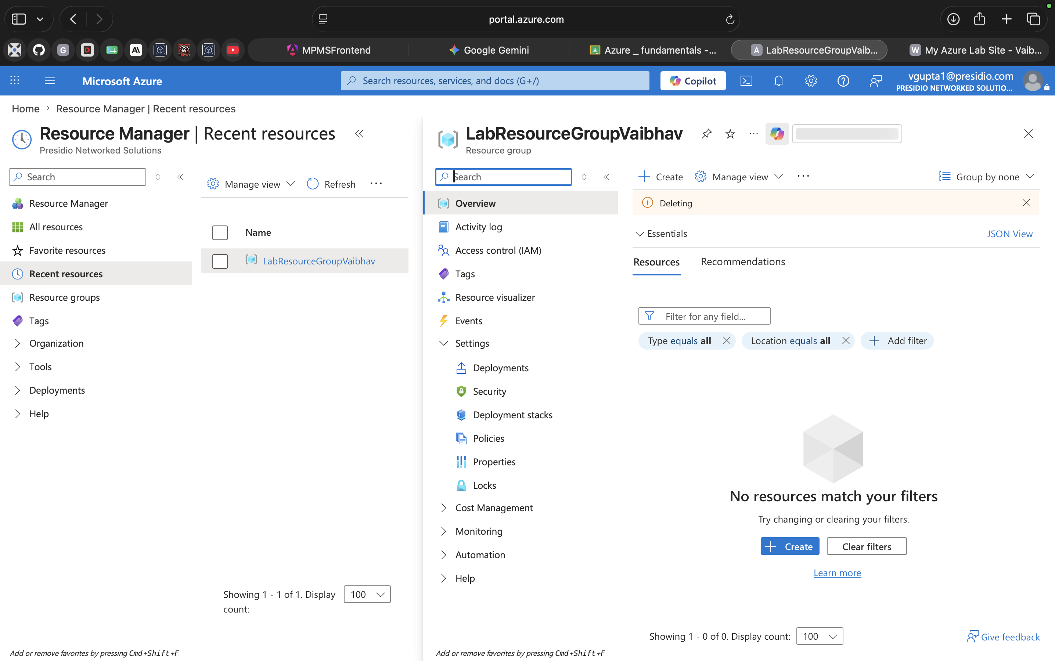

Option B: Delete Resources Individually
- Virtual machine: open the VM, select “Delete”, and also delete the associated disk, network interface, public IP, and network security group shown on the VM's Overview page.
- SQL Database and server: open the SQL server resource, select “Delete” (this also offers to delete databases on that server).
- Storage account: open the storage account, select “Delete”, and confirm by typing the account name.
Warning — Cost Control
A virtual machine continues to bill for compute time while running, and for attached disks even when stopped. Always delete or fully deallocate resources you no longer need.

Summary
In this lab manual you created and configured four foundational Azure resources entirely through the Azure Portal: a virtual machine, an Azure SQL Database, a Blob Storage container with an uploaded image, and a static HTML website. These exercises cover compute, database, and storage — three of the core pillars of the Azure platform — and provide a foundation for more advanced labs involving networking, security, and automation.

Further Reading
Create a Windows VM in the Azure portal
Create a single Azure SQL database (portal)
Upload, download, and list blobs (Azure portal)
Host a static website in Azure Storage

